**Amazon Web Services – Level – 2**

**Case 1**

1. **Login to AWS Management console using root account. For root account MFA must be enabled.**

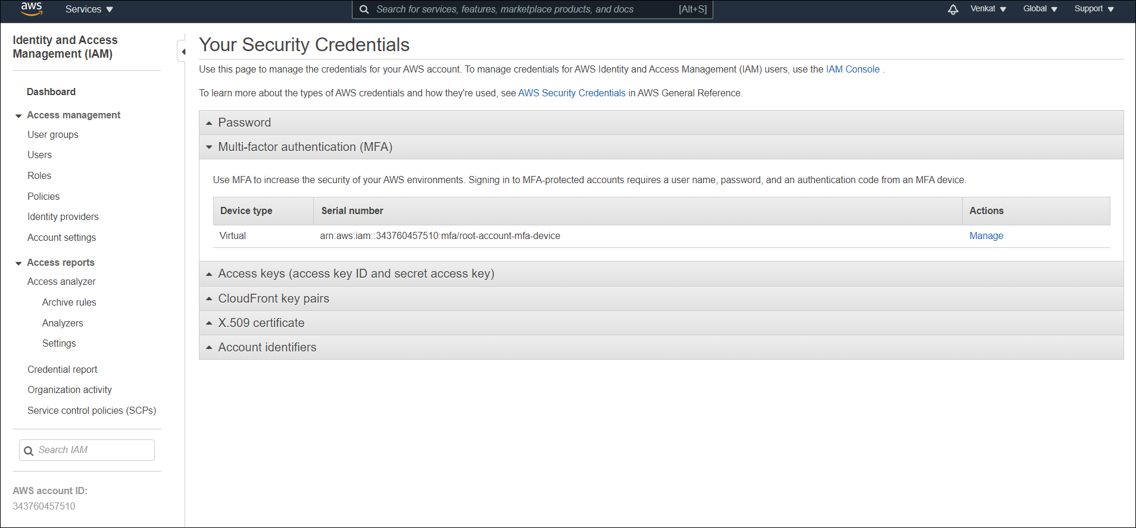

1. **Create two groups called storage-admin, compute-admin. In each group create three users stadmin1…stadmin3, compadmin1…compadmin3.**

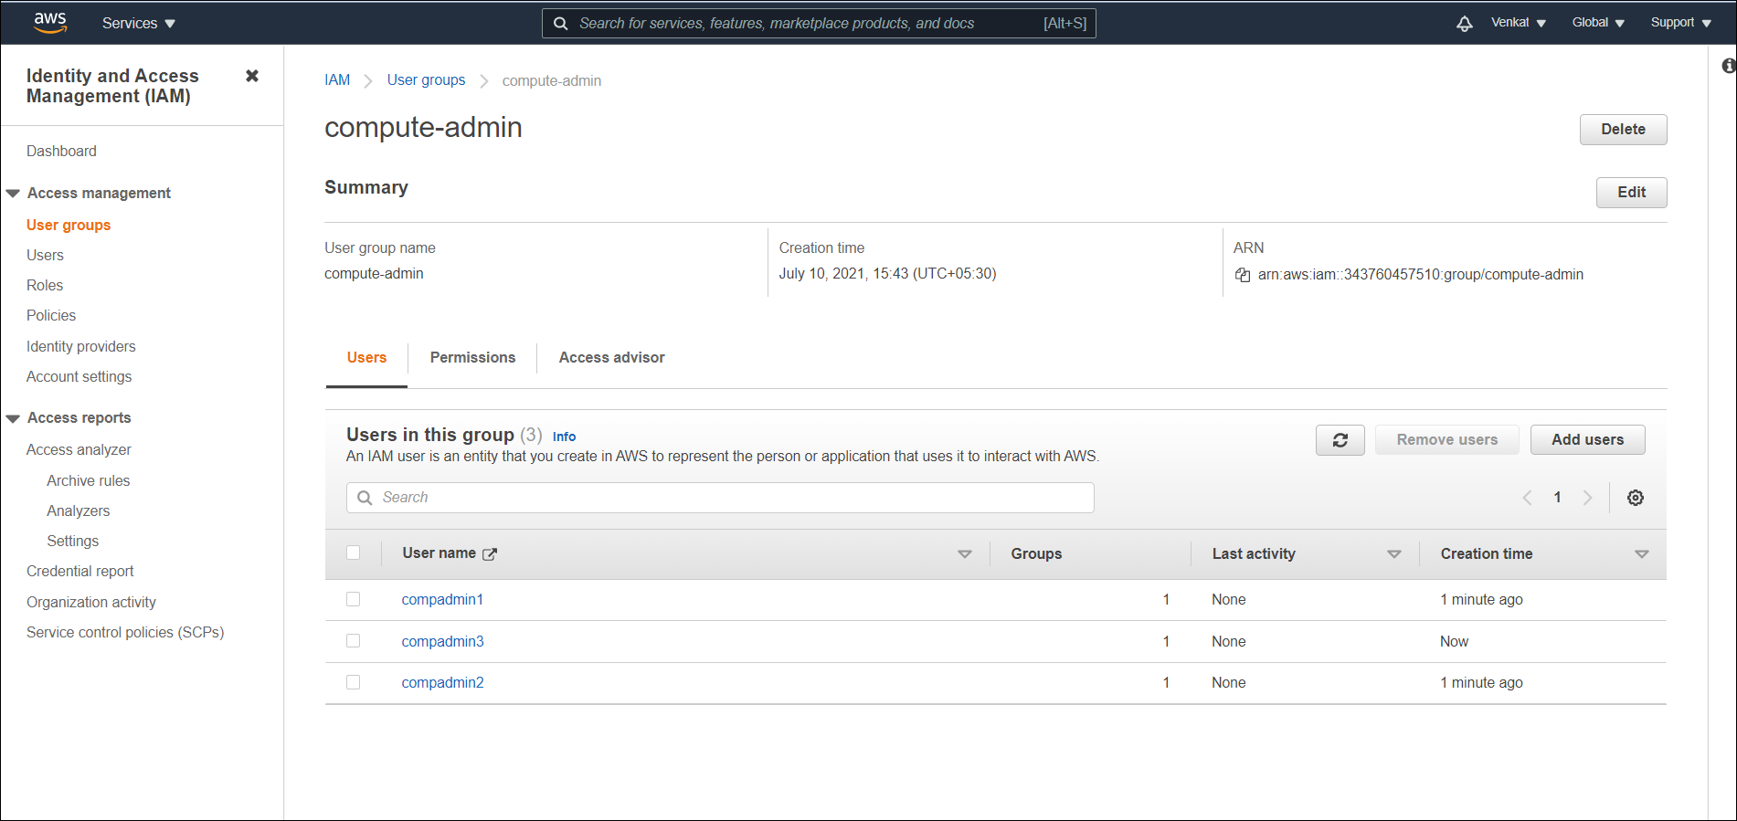

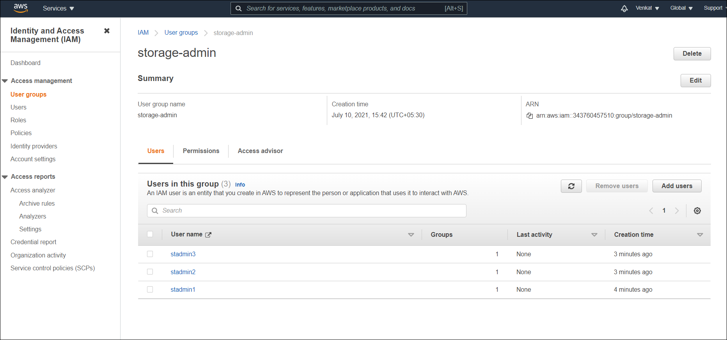

**In storage-admin group every user must have storage-viewer role, except stadmin2, it should have full access to storage.**

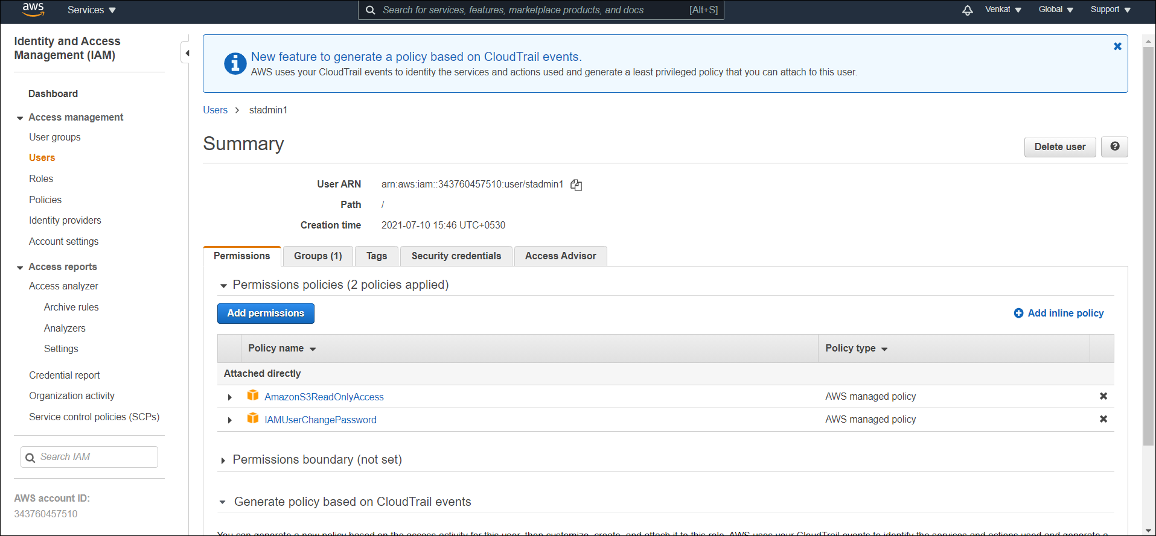

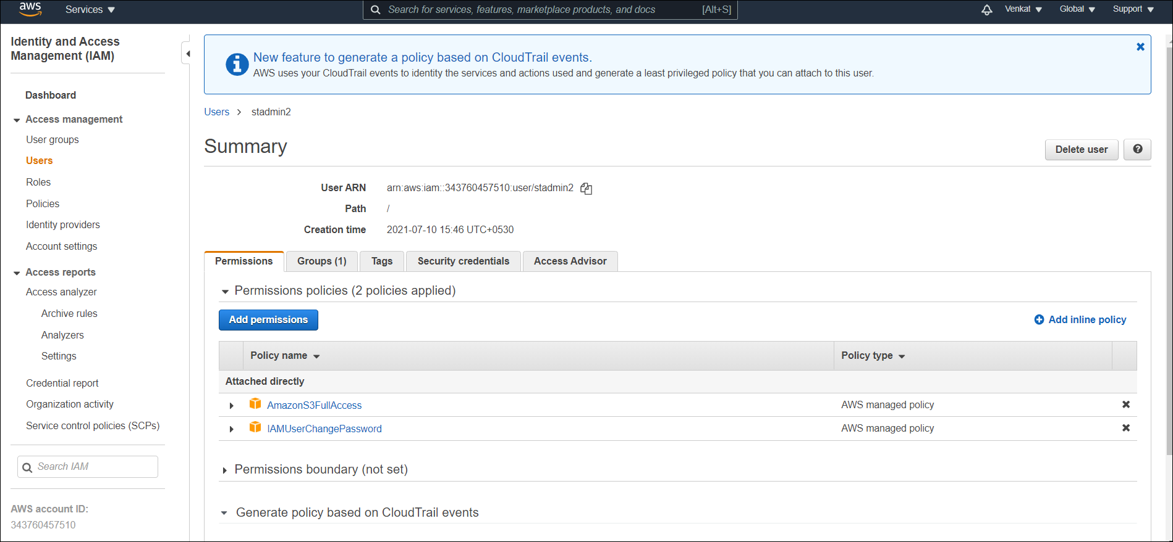

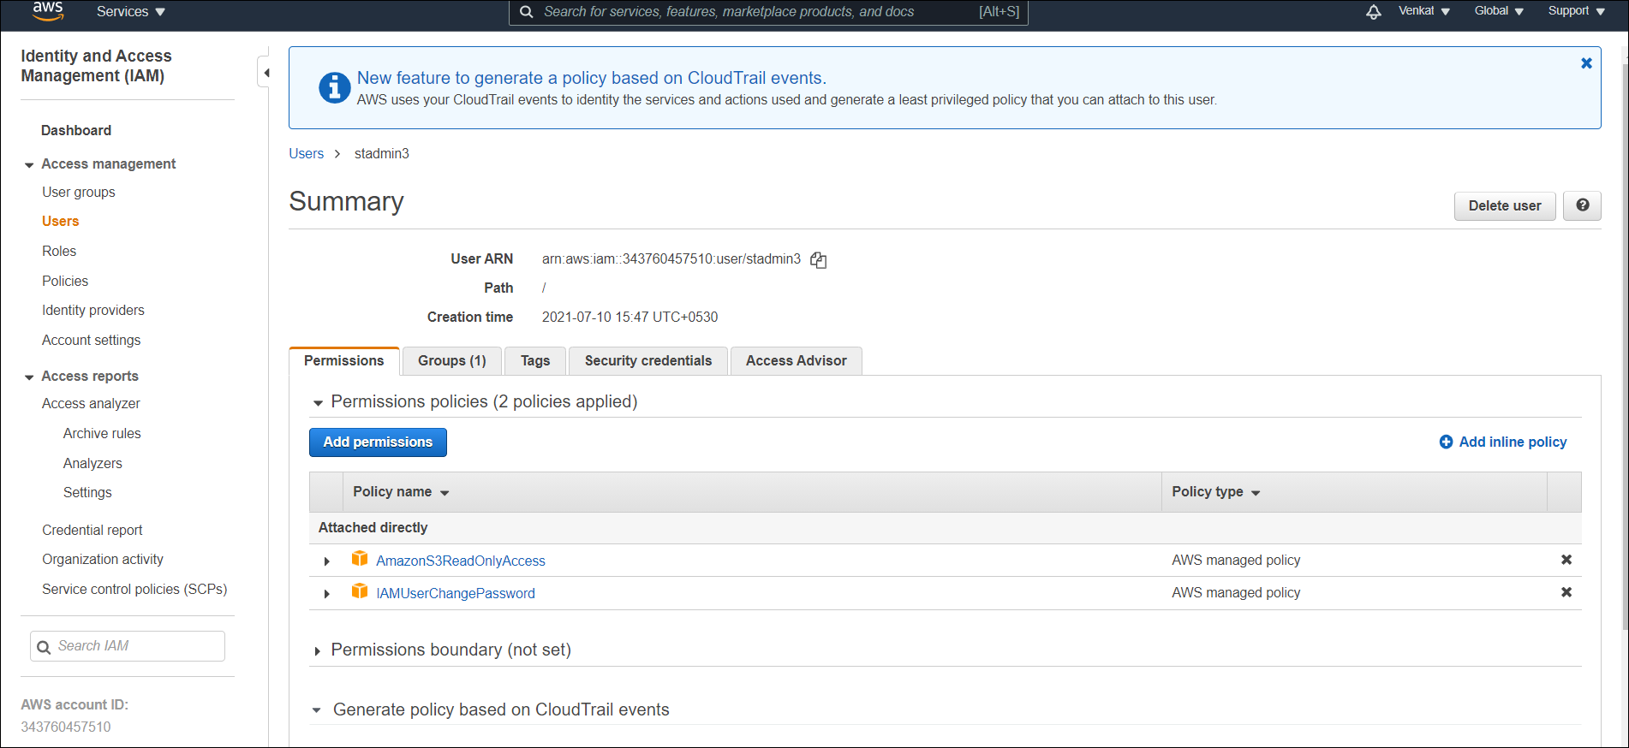

**Compadmin1 must have application deployment authority. All the users of comp-admin group should have full access of EC2.**

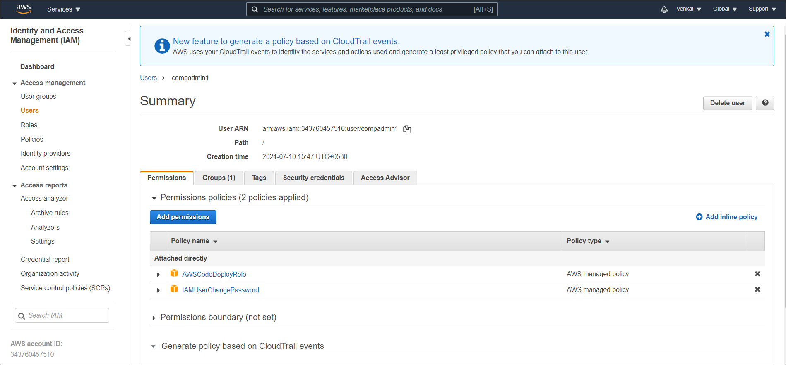

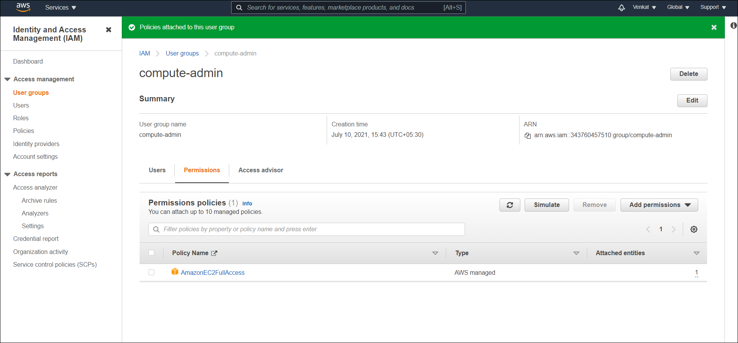

**Create a S3 bucket as yourfirstname-ddmmyyyy-store, create a IAM user who should have get and list authorization on that specific bucket**

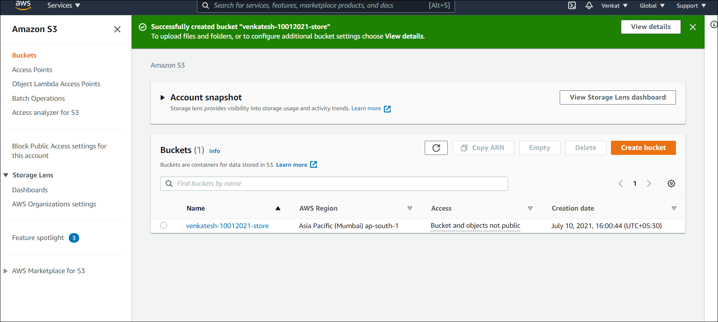

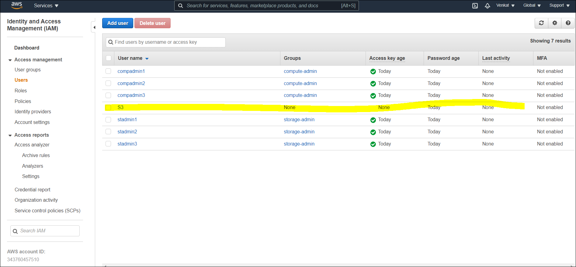

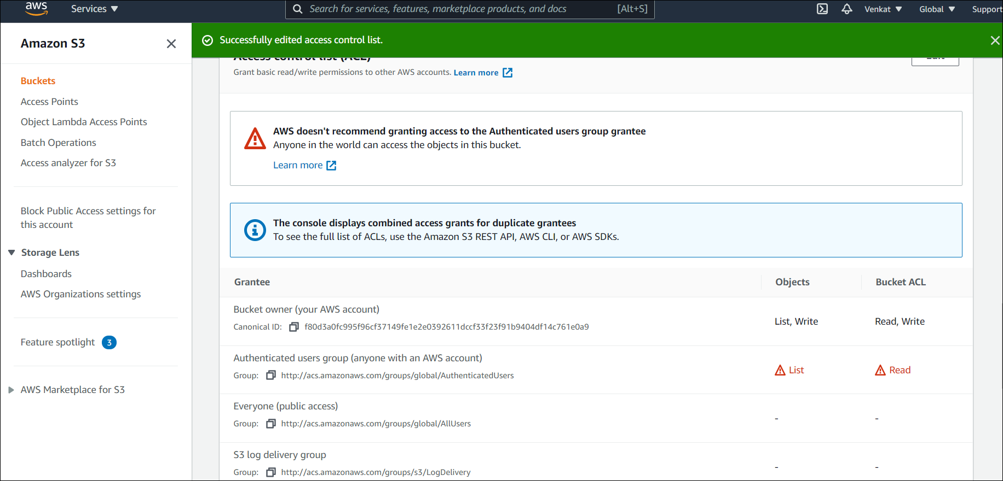

**Case 2**

**Create a VPC in any given region of your choice as yourfirstname-vpc-ddmmyyy.**

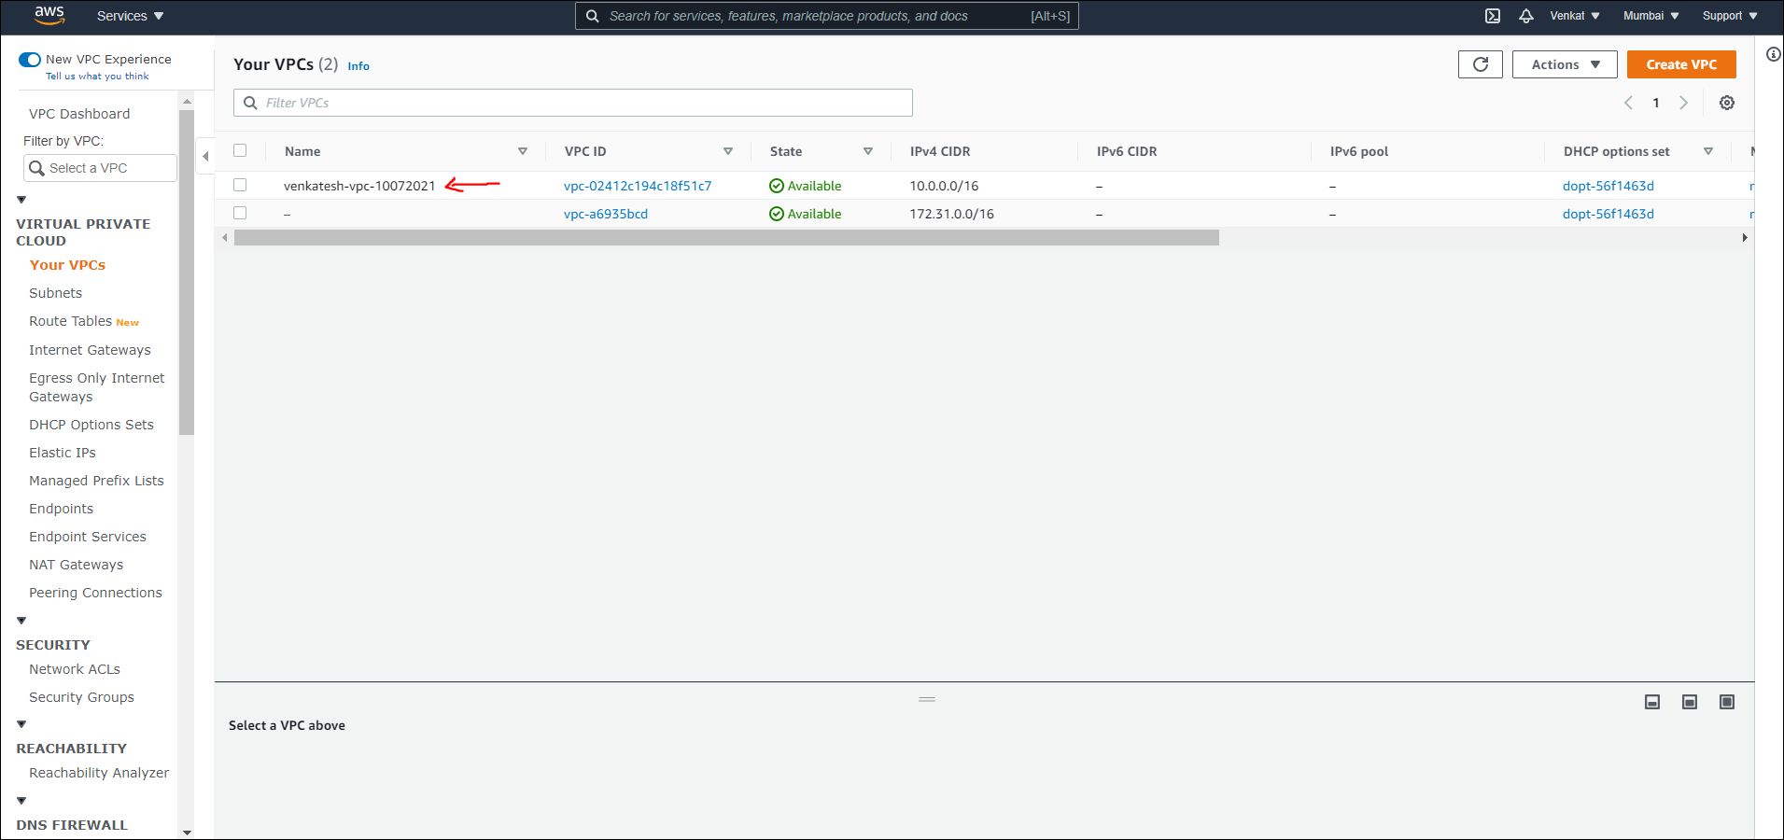

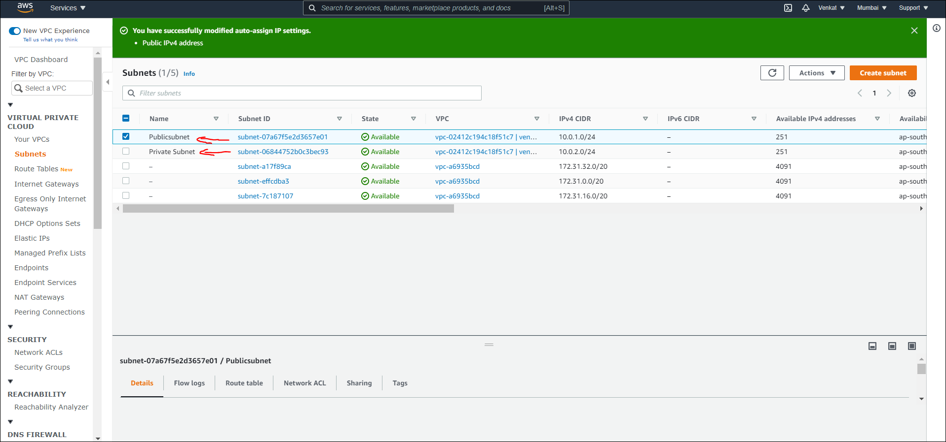

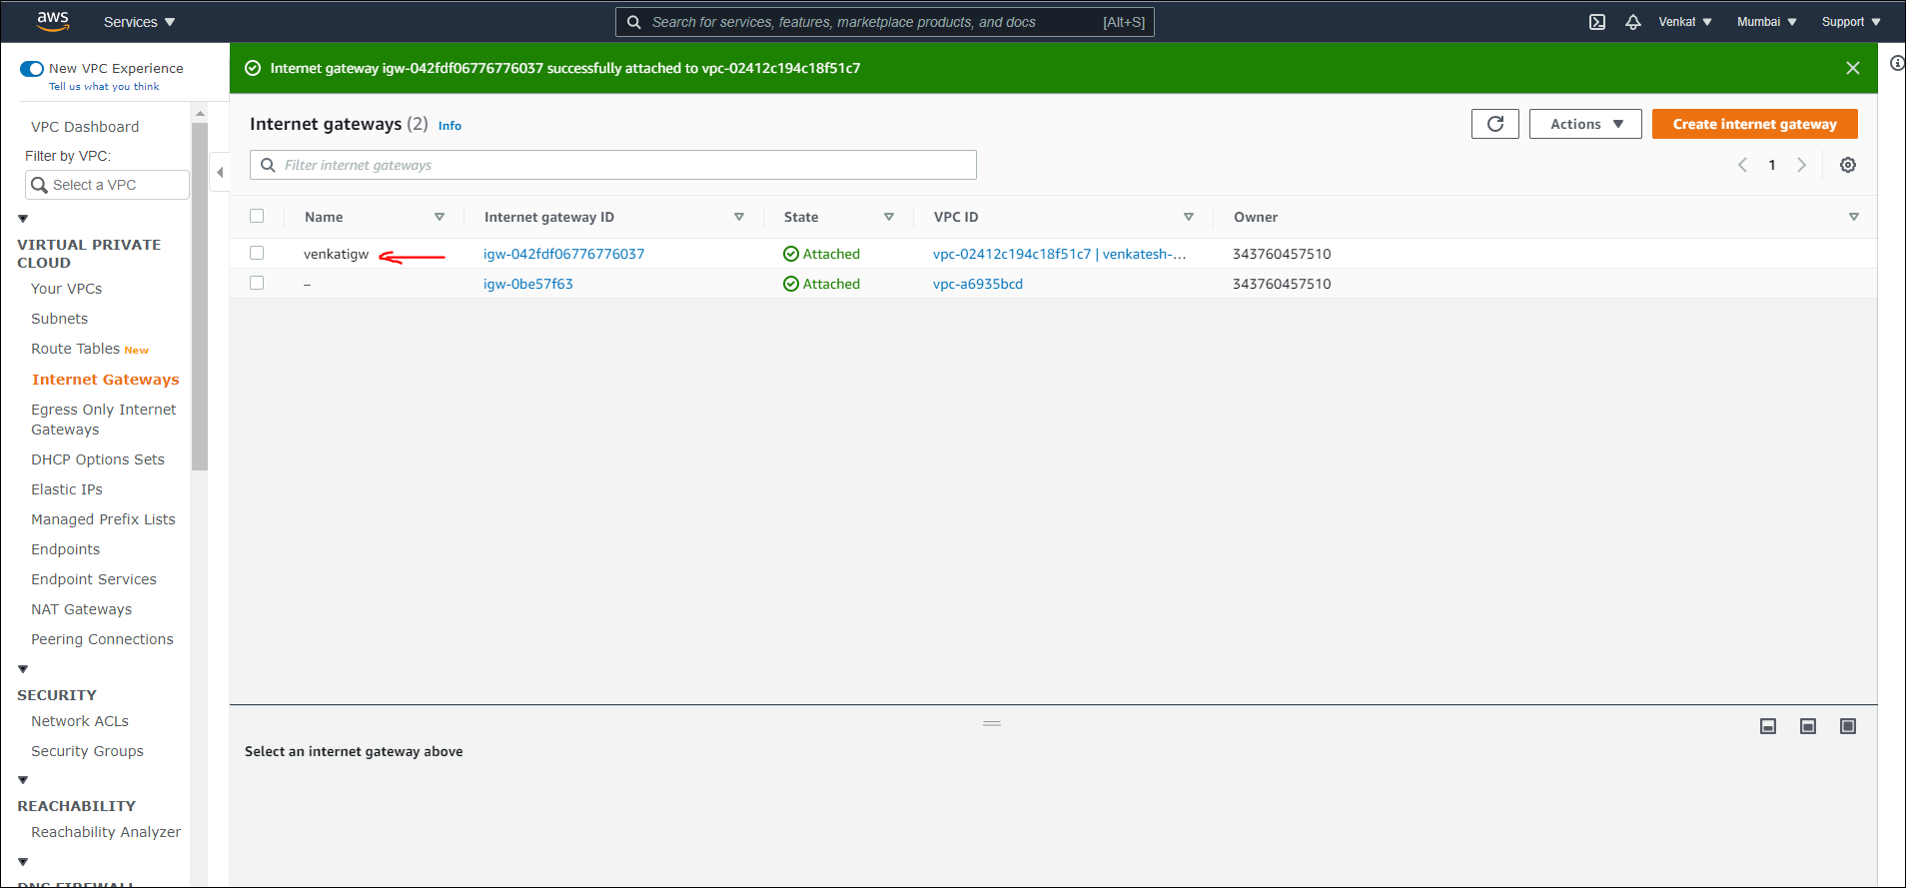

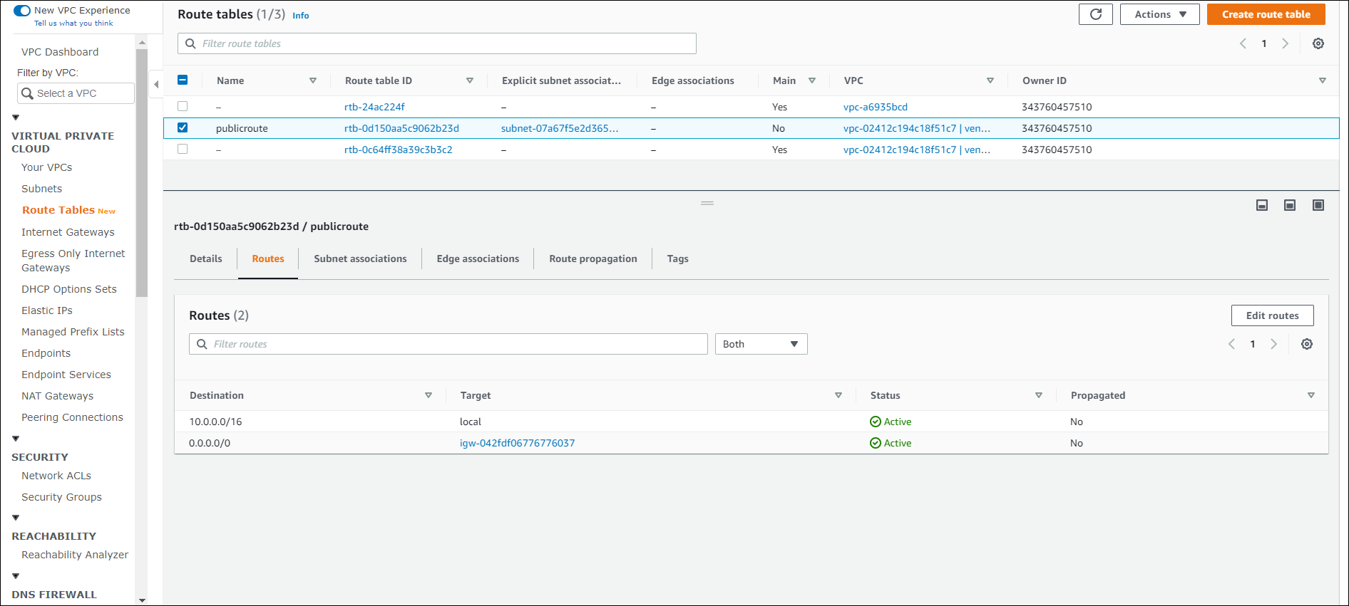

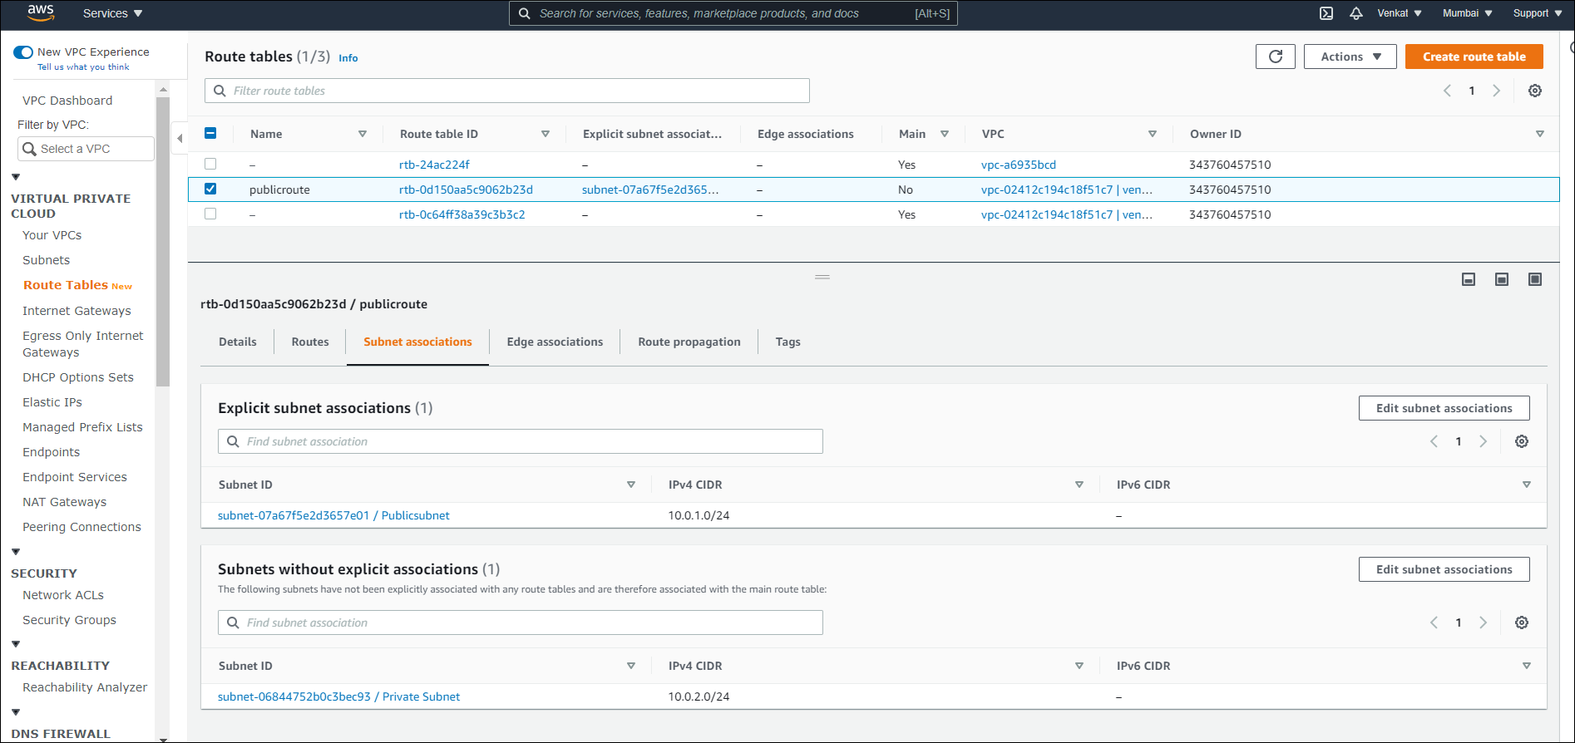

**The first subnet should be able to interact with internet and accept incoming ssh, http, https, icmp requests.**

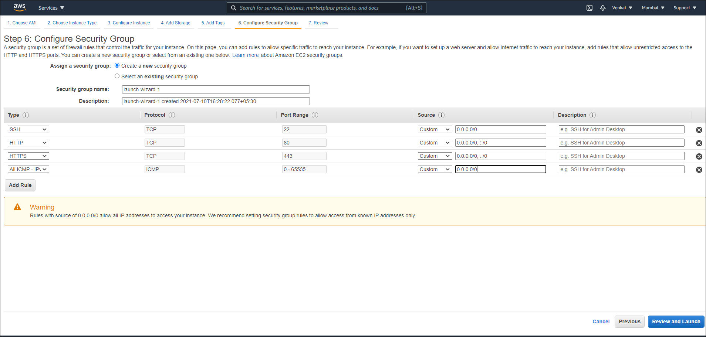

**The second subnet should be internal. But EC2 instances created in this subnet should be able to interact with the first subnet.**

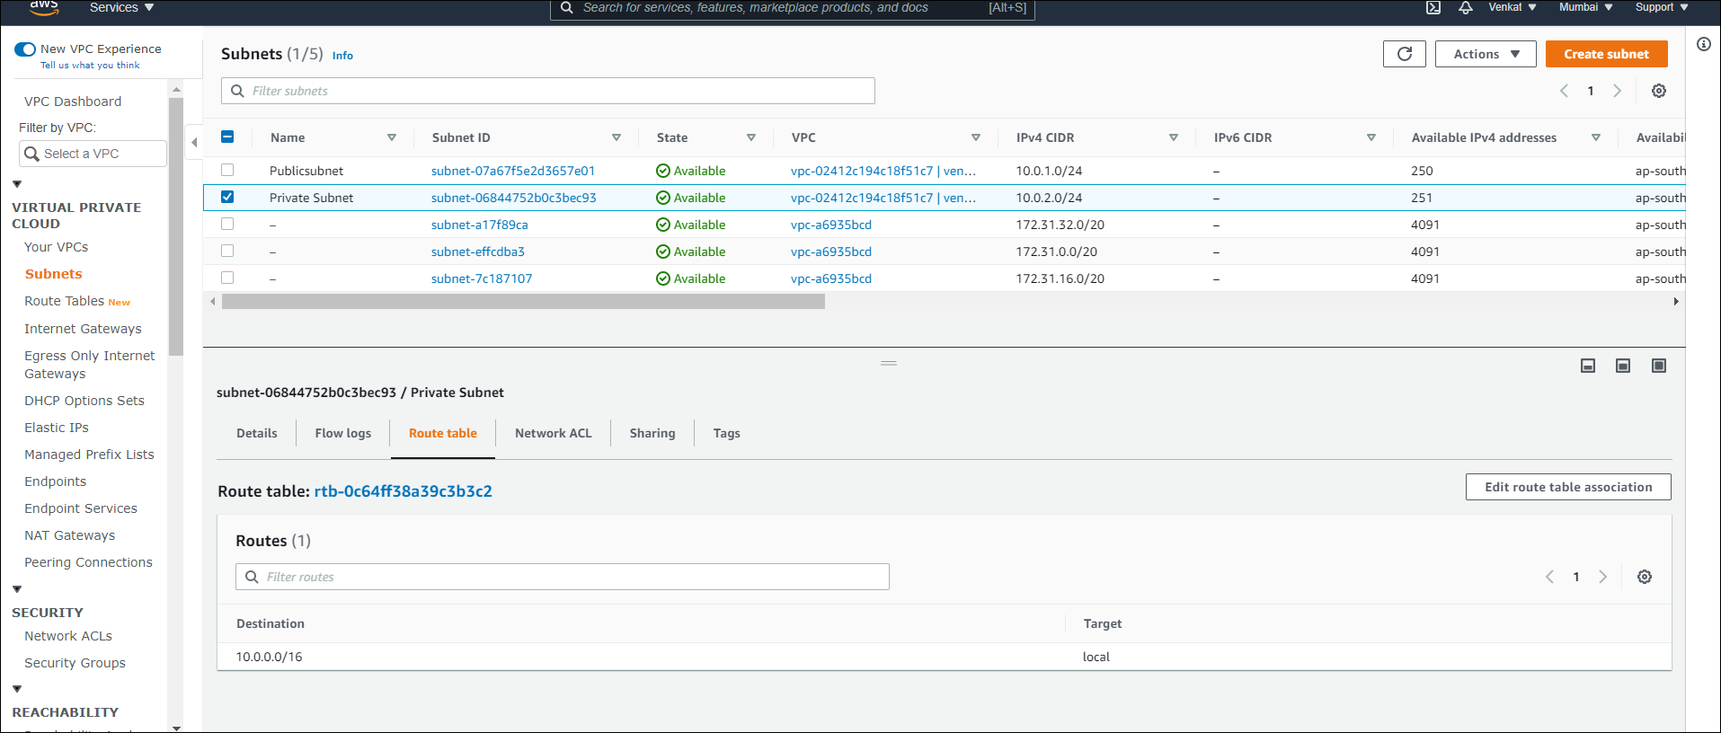

**Case 3**

**Create a EC2 instance on the first subnet on the VPC created in the above case. The instance should be of Linux type. Test whether you are able to connect that from your own laptop/Desktop from external network. Enable monitoring while creating the instance.**

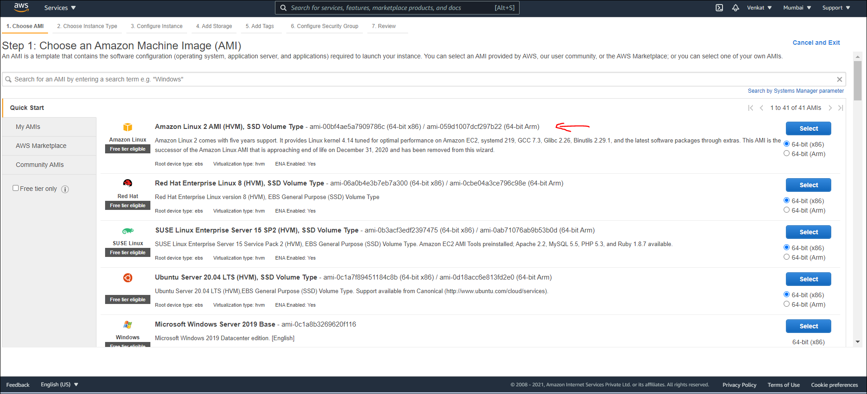

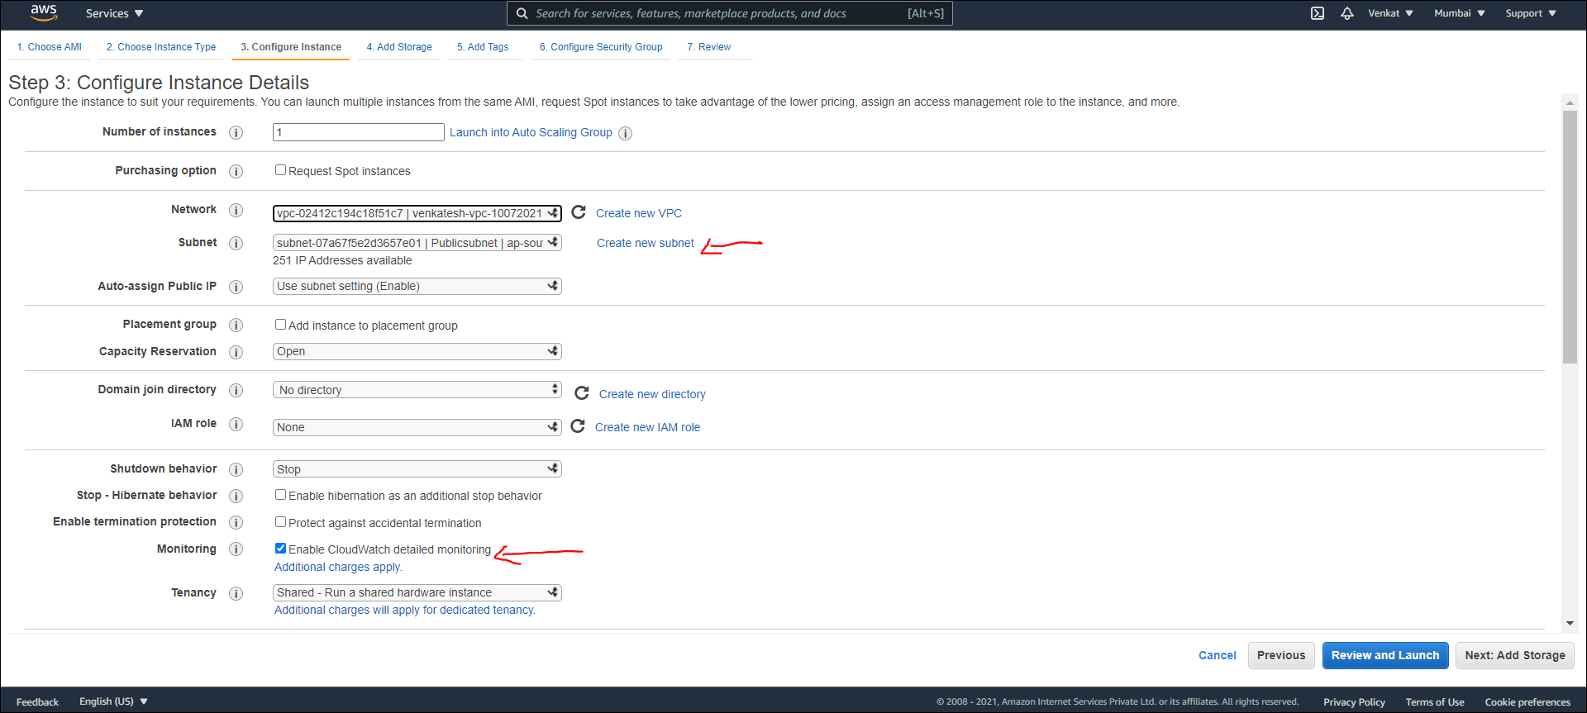

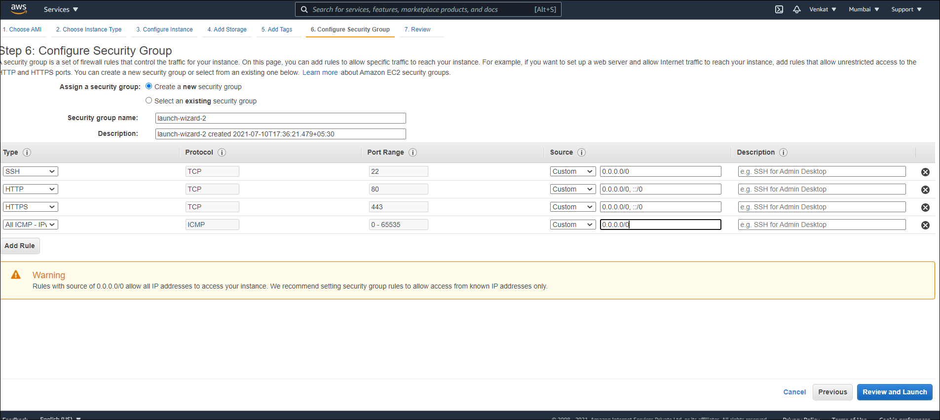

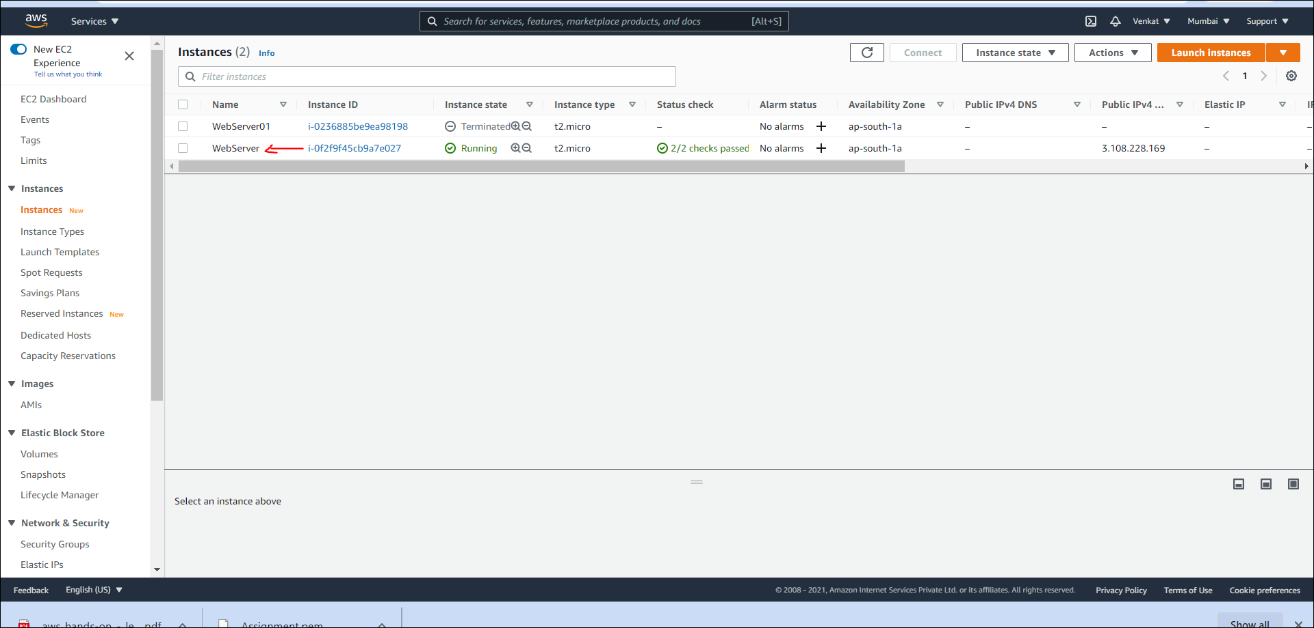

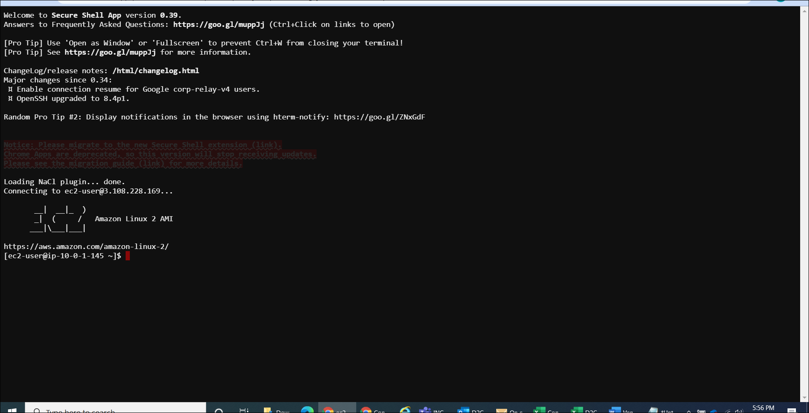

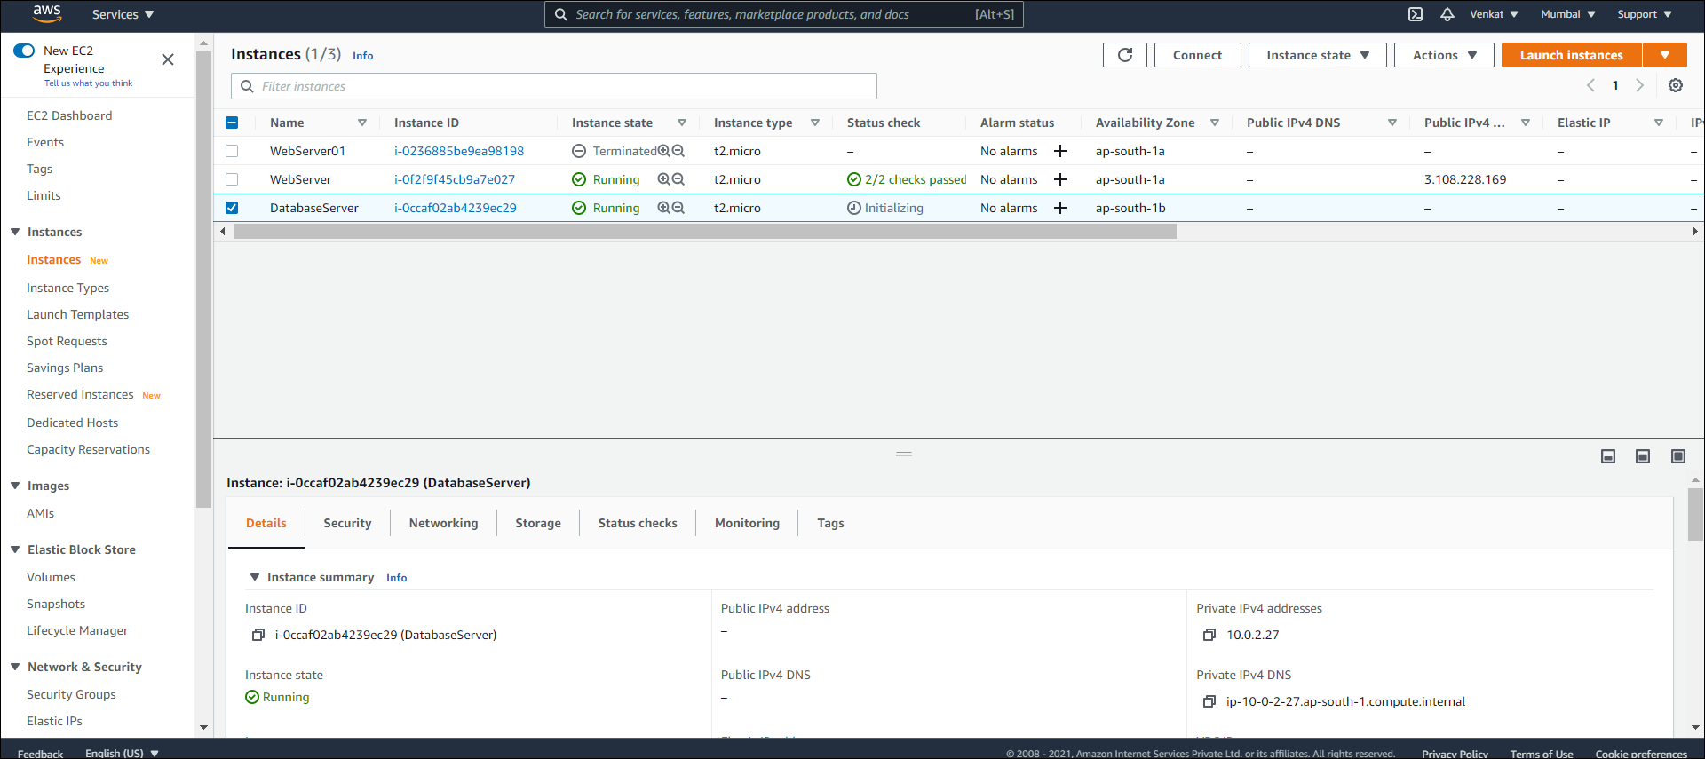

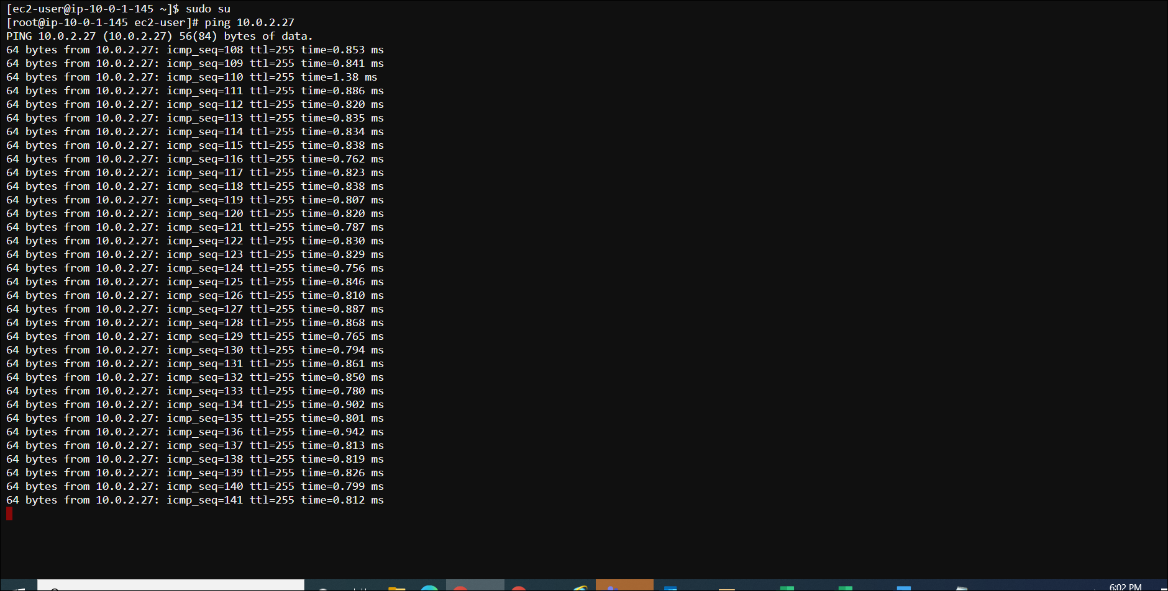

**Add a EBS volume in the first VM, the size of the volume should be 5GB. Show the information, that the disk is attached to the first VM.**

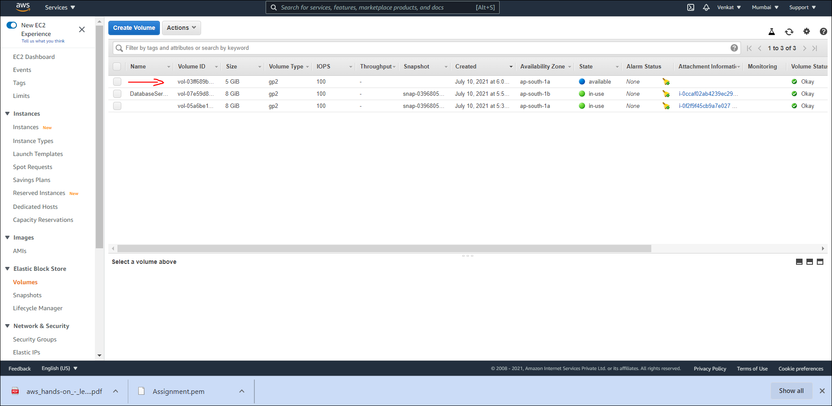

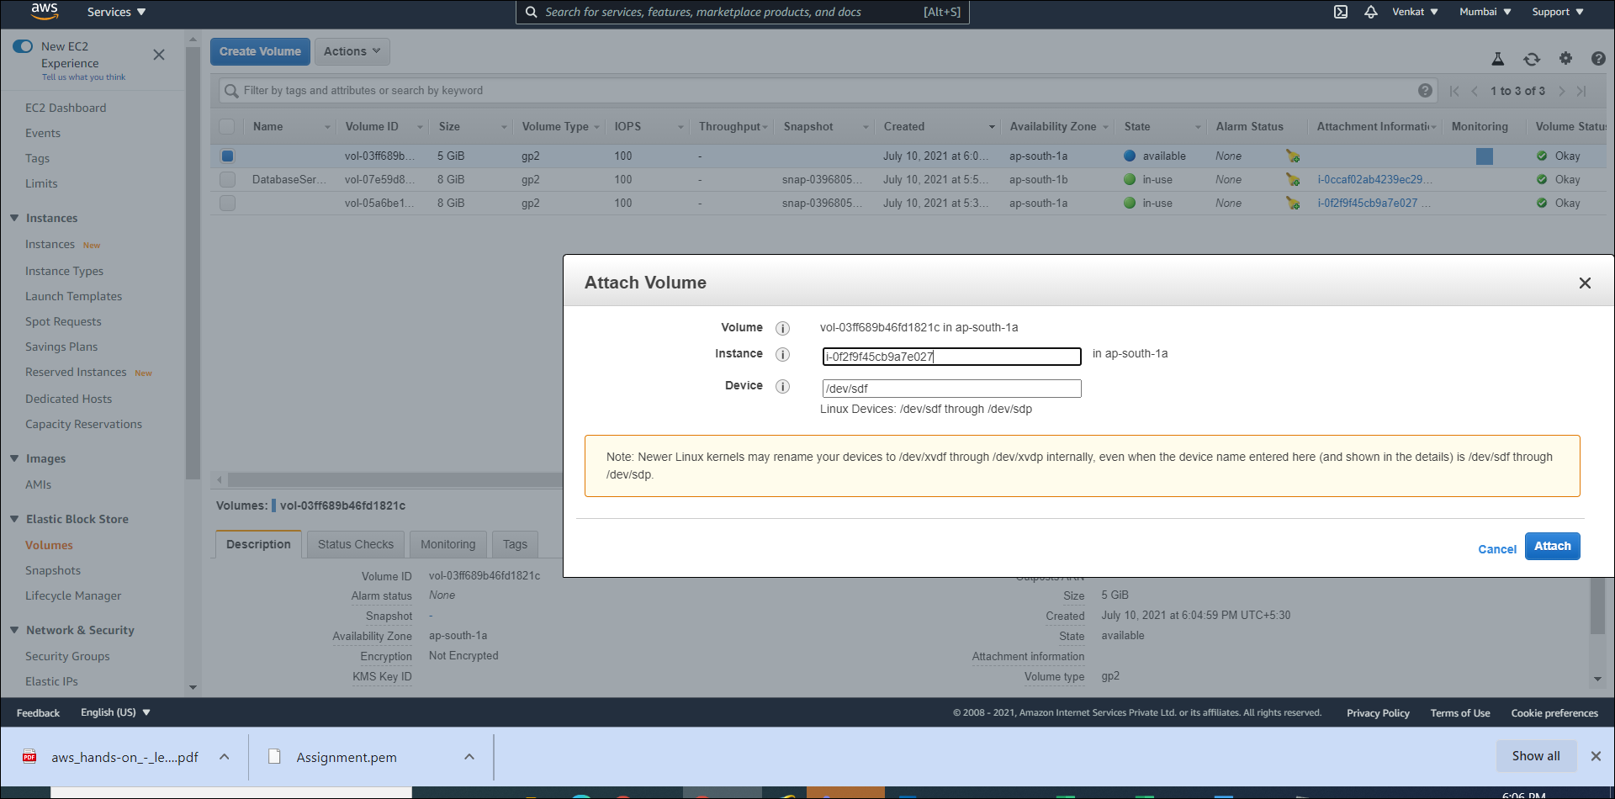

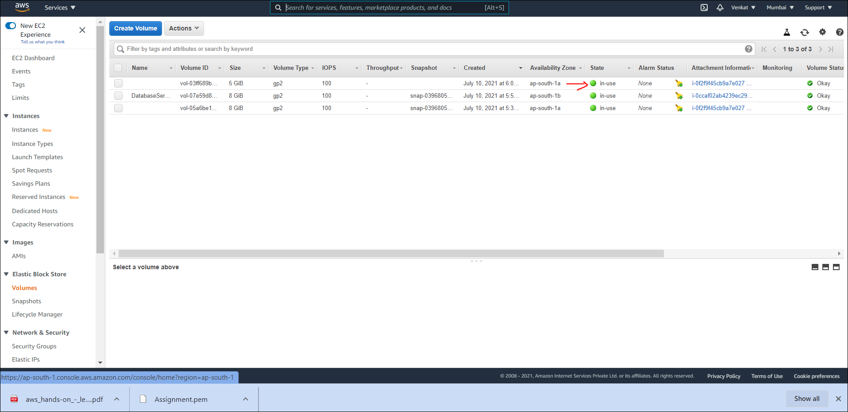

**From the CloudWatch dashboard enable event monitoring of EC2. Shutdown the first VM and start that again. Check the dash board whether those events are captured.**

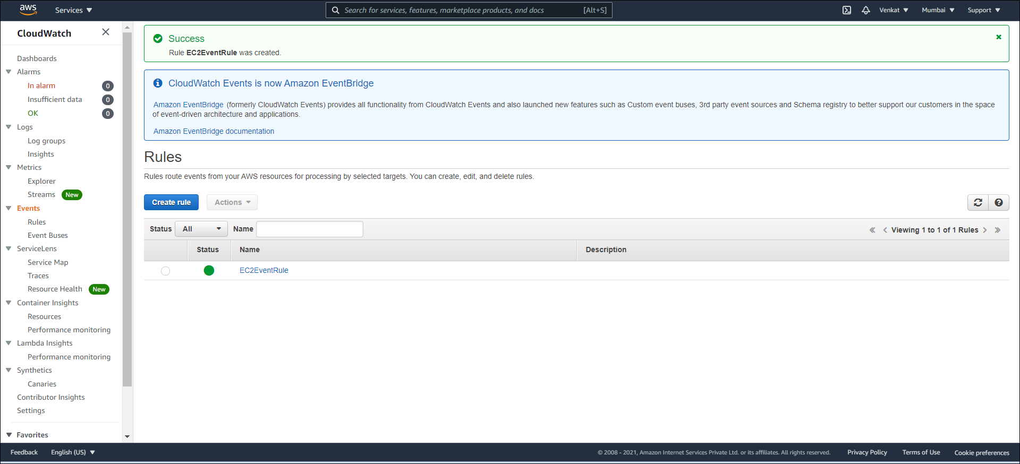

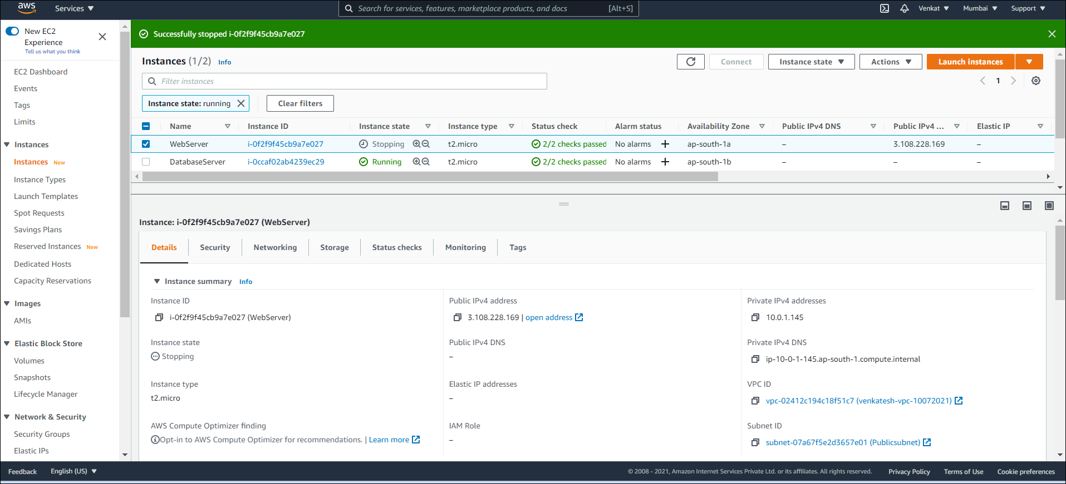

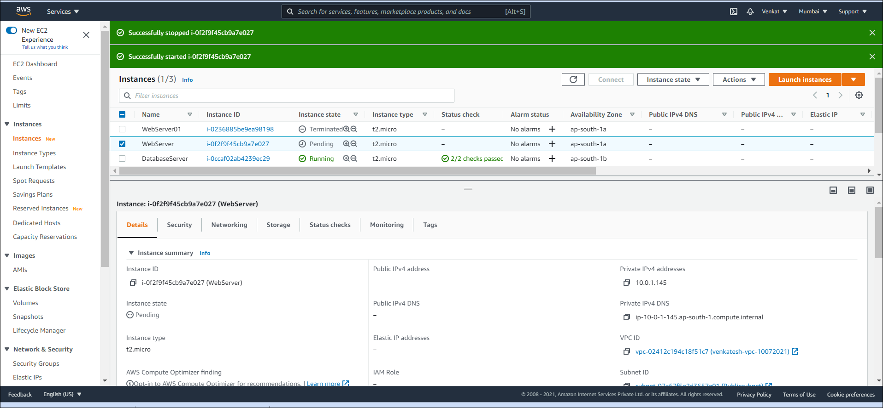

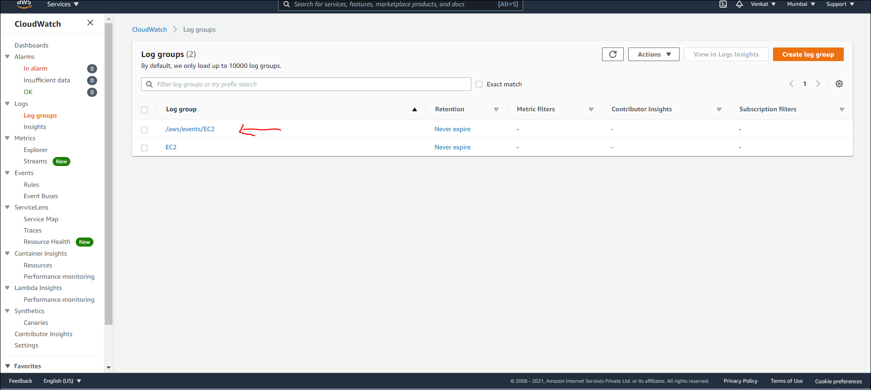

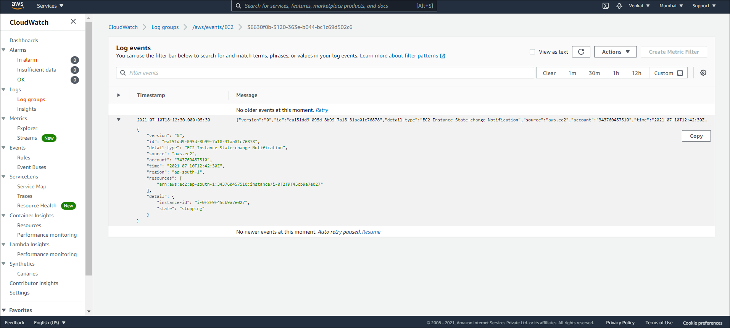

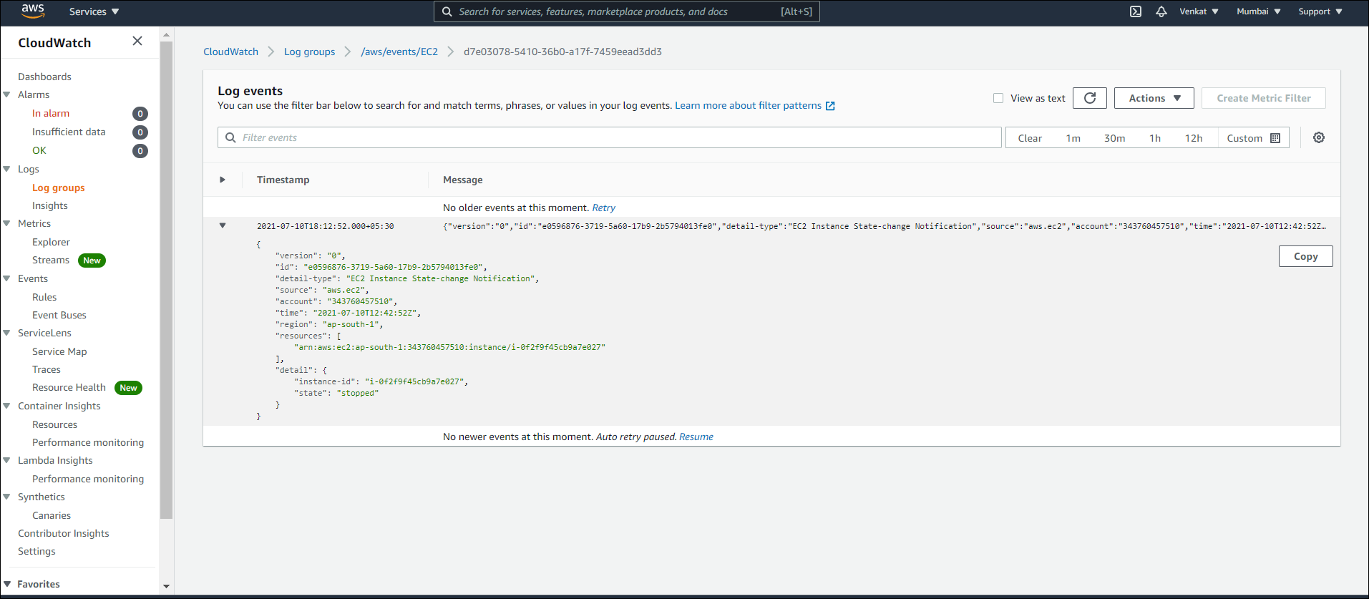

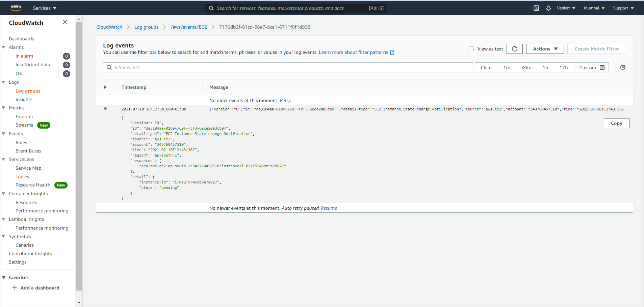

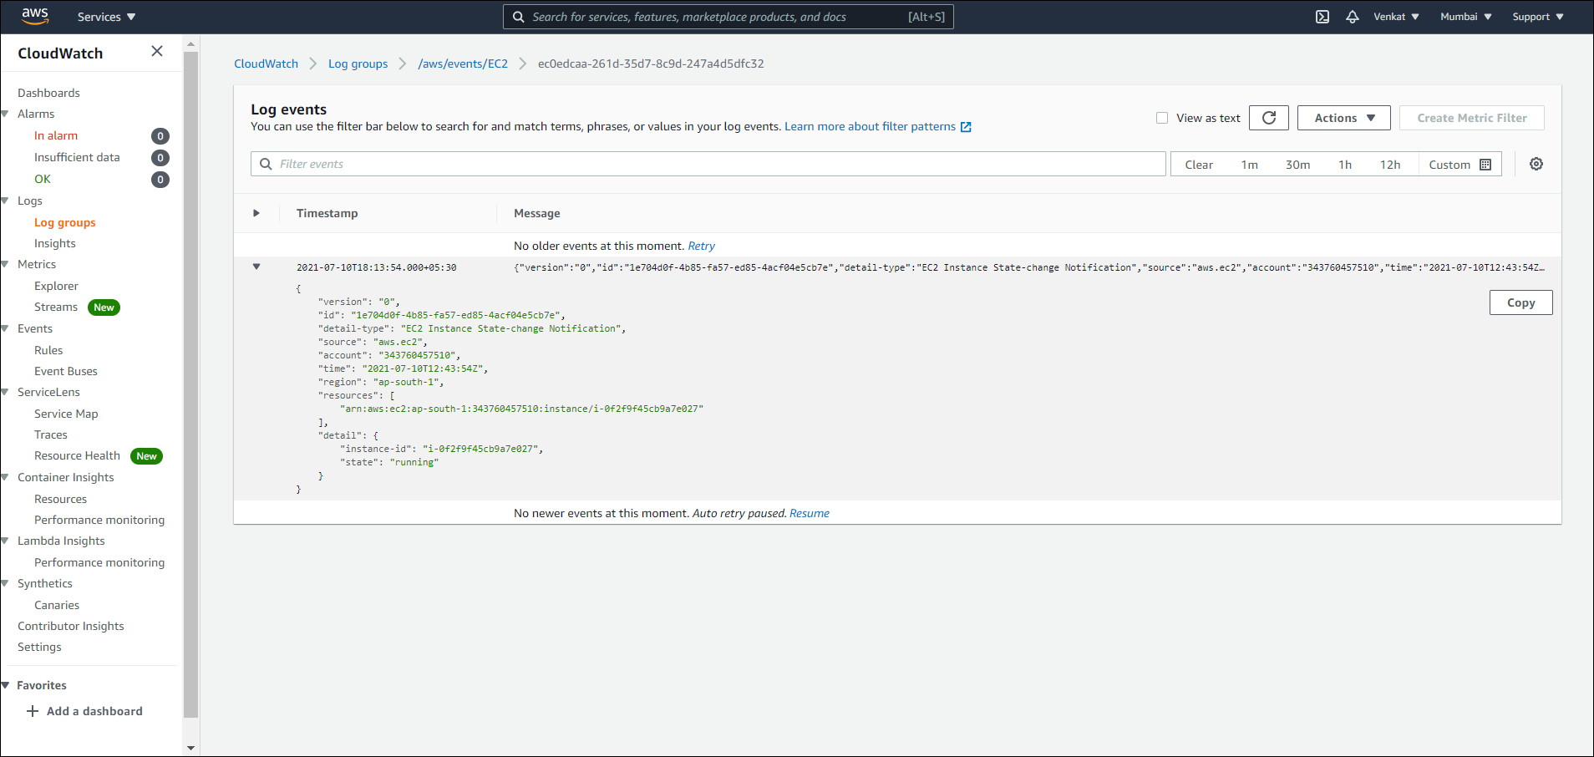

**Case 4:**

**Create a storage bucket as yourfirstname-emplyeeid. Enable versioning for that bucket.**

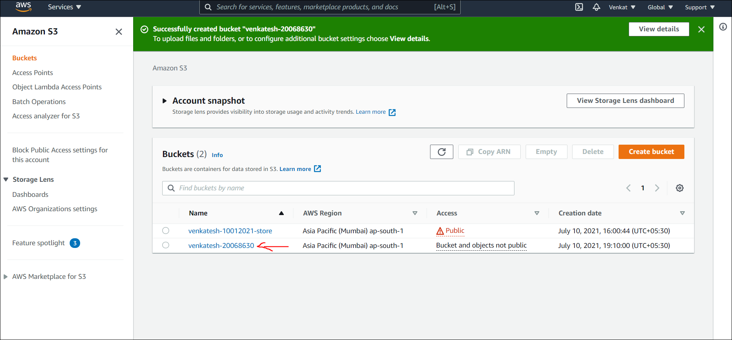

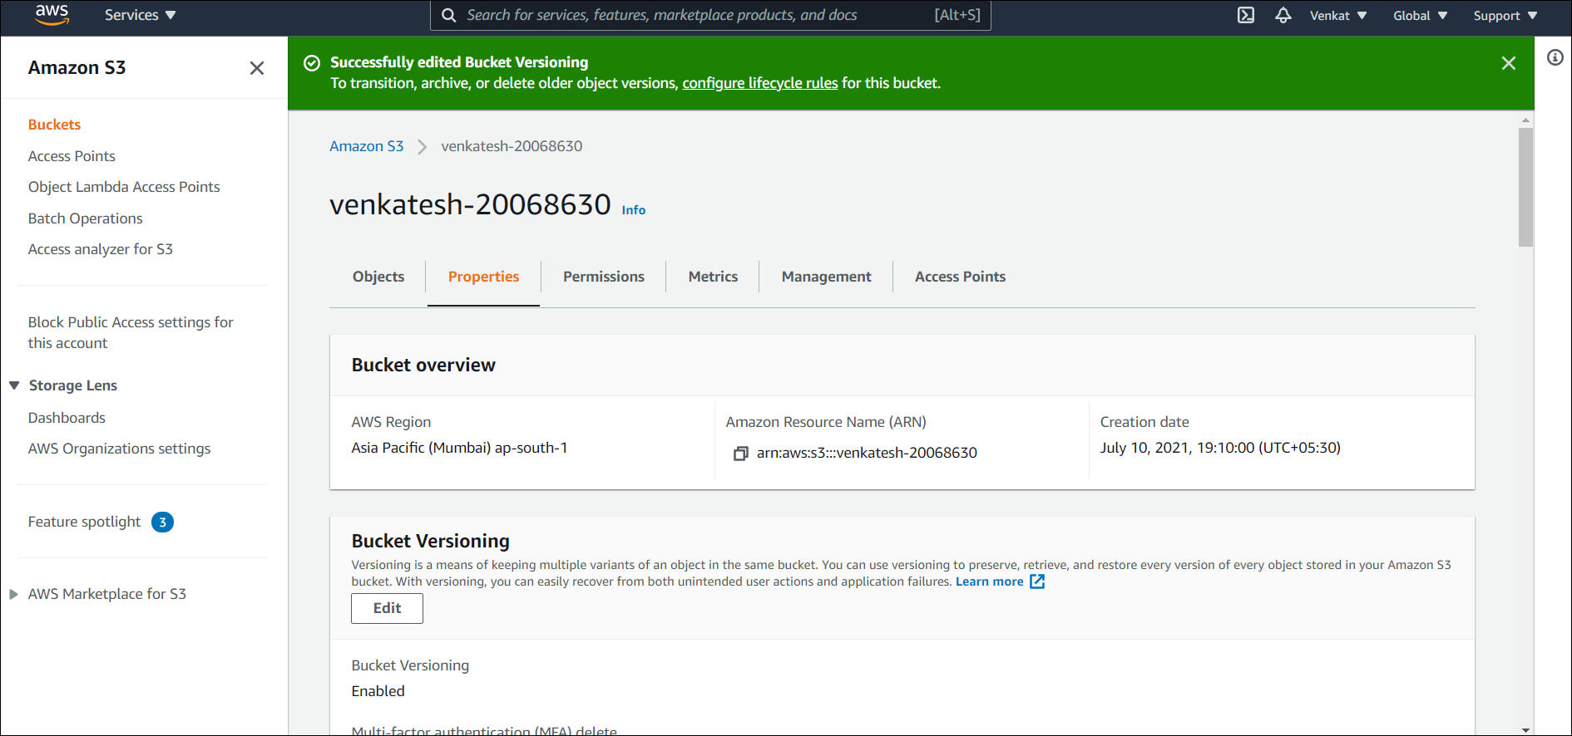

**Enable life-cycle rule for that bucket as: First 30 days in S3-Standard Next 100 days in S3-Standard-IA Next 100 days in S3 Glacier and then expire**

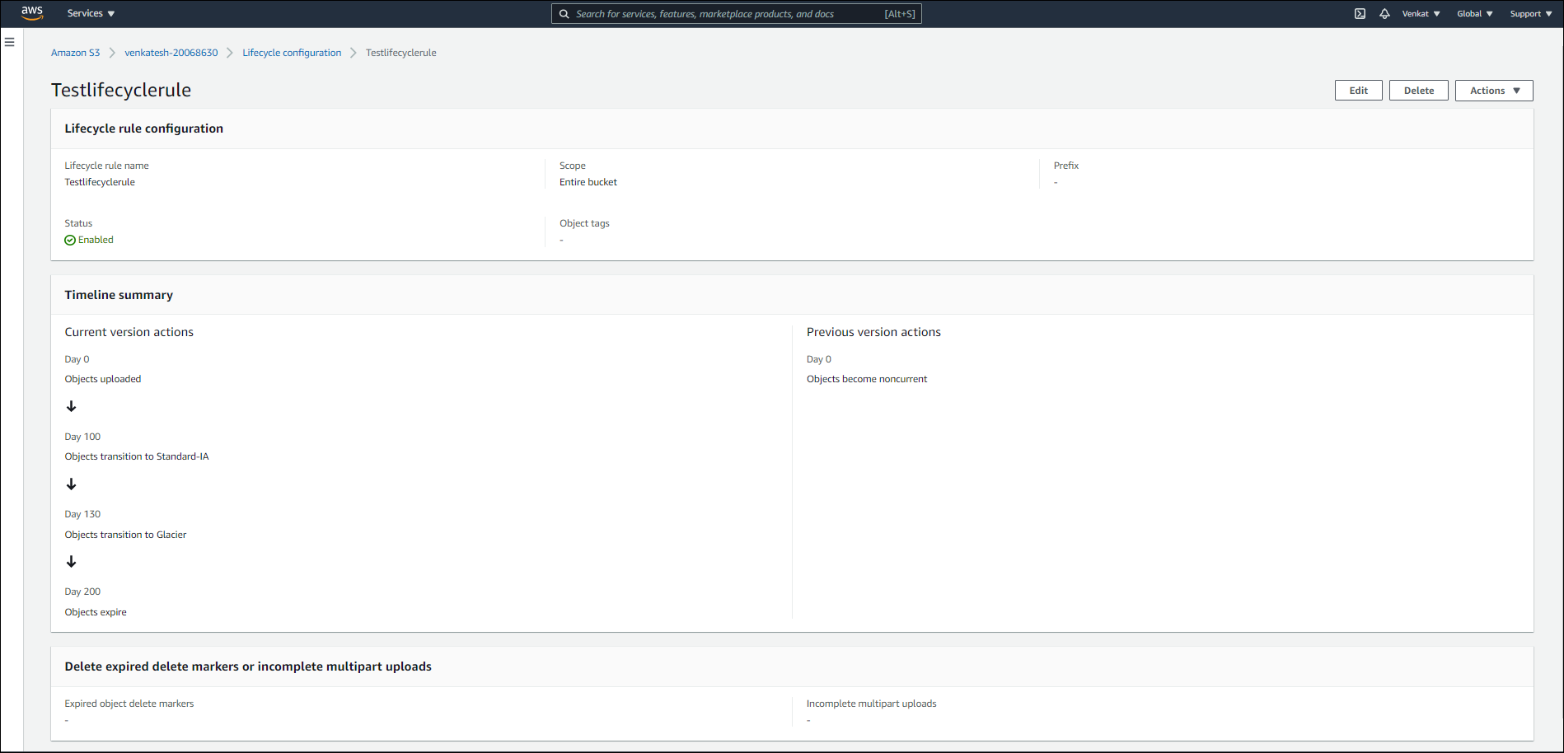

**In the bucket upload 3 jpeg or png or gif files from command line and a .txt file from console**

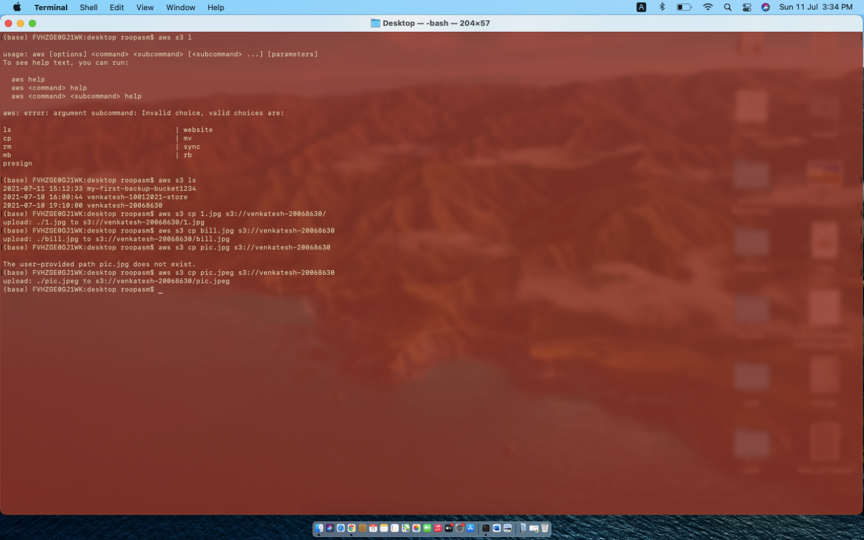

**After a while modify the text file by writing some new lines and again upload from command line.**

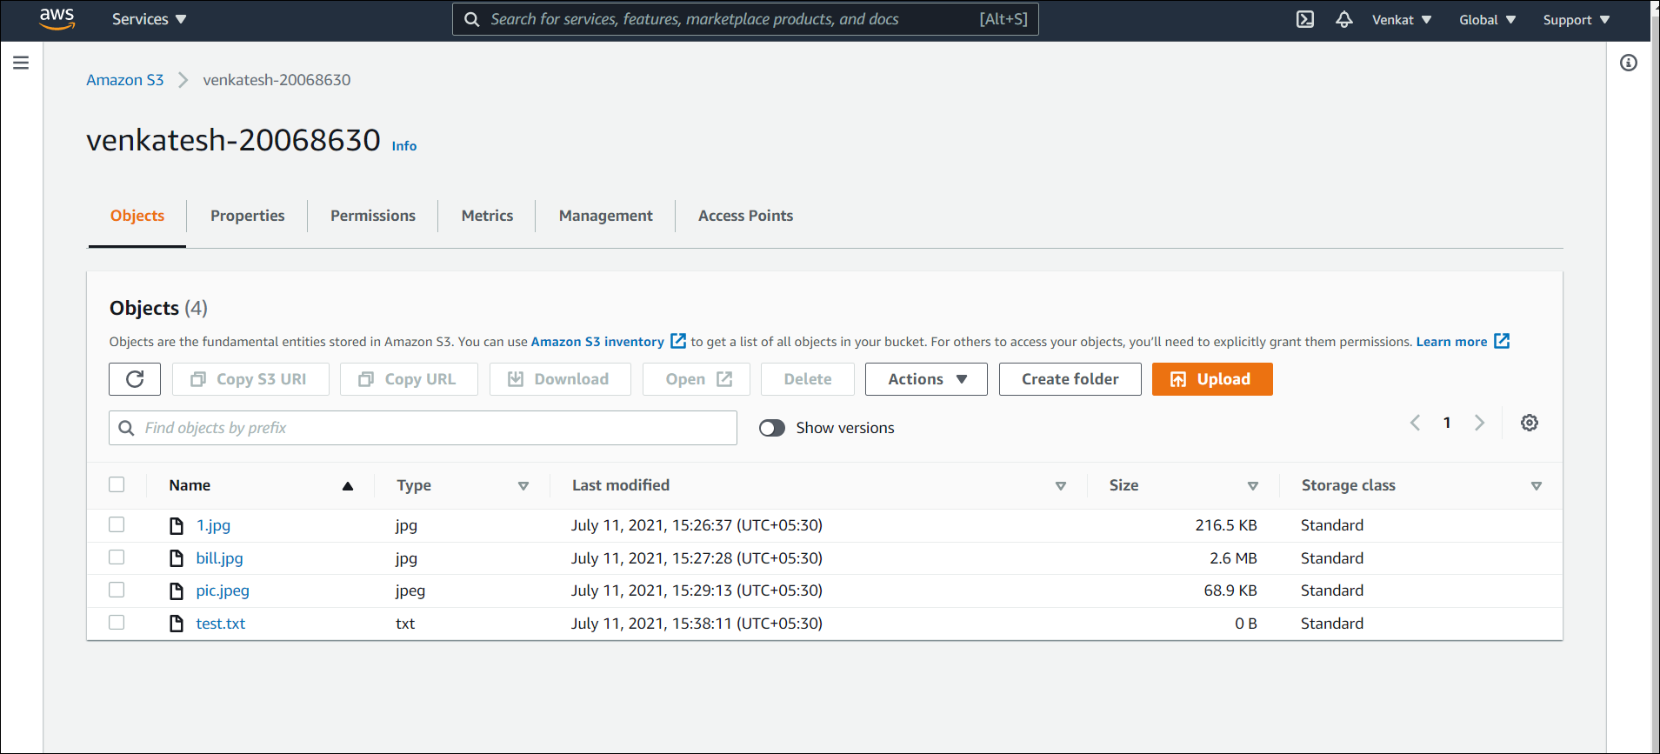

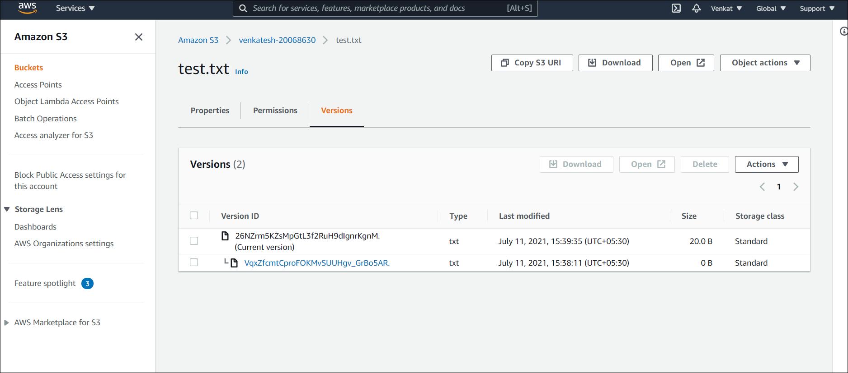

**Now, login to the console by using the stadmin1 user’s credential and check whether it can view the content.**

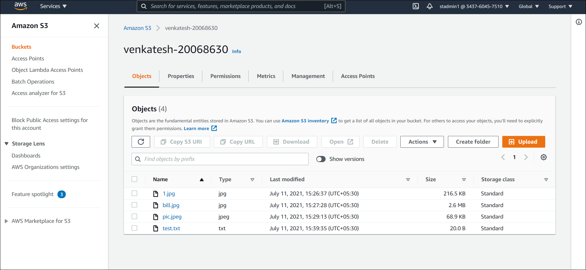

**Logout from stadmin1 and log-in using stadmin2 and check whether it can create new bucket and upload file.**

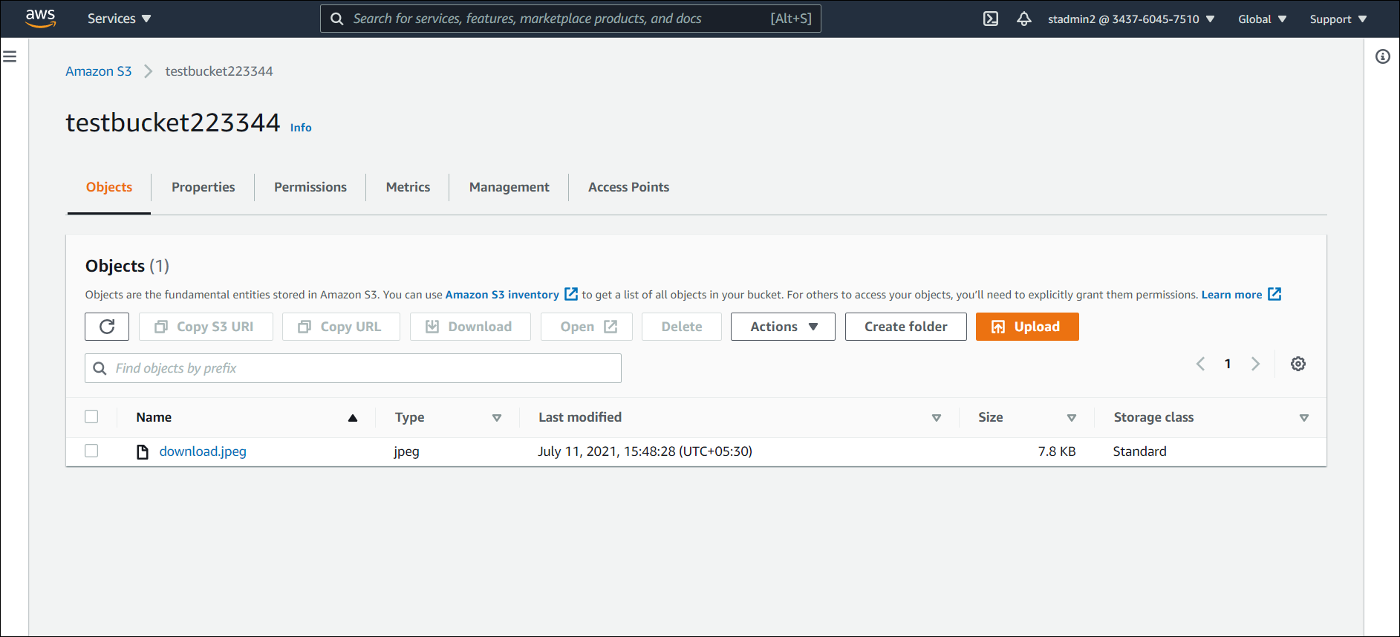

**Create another S3 bucket, provide name as per your choice, use the bucket to host static website. Provide public access to that and check from outside whether everyone can access the content of the site.**

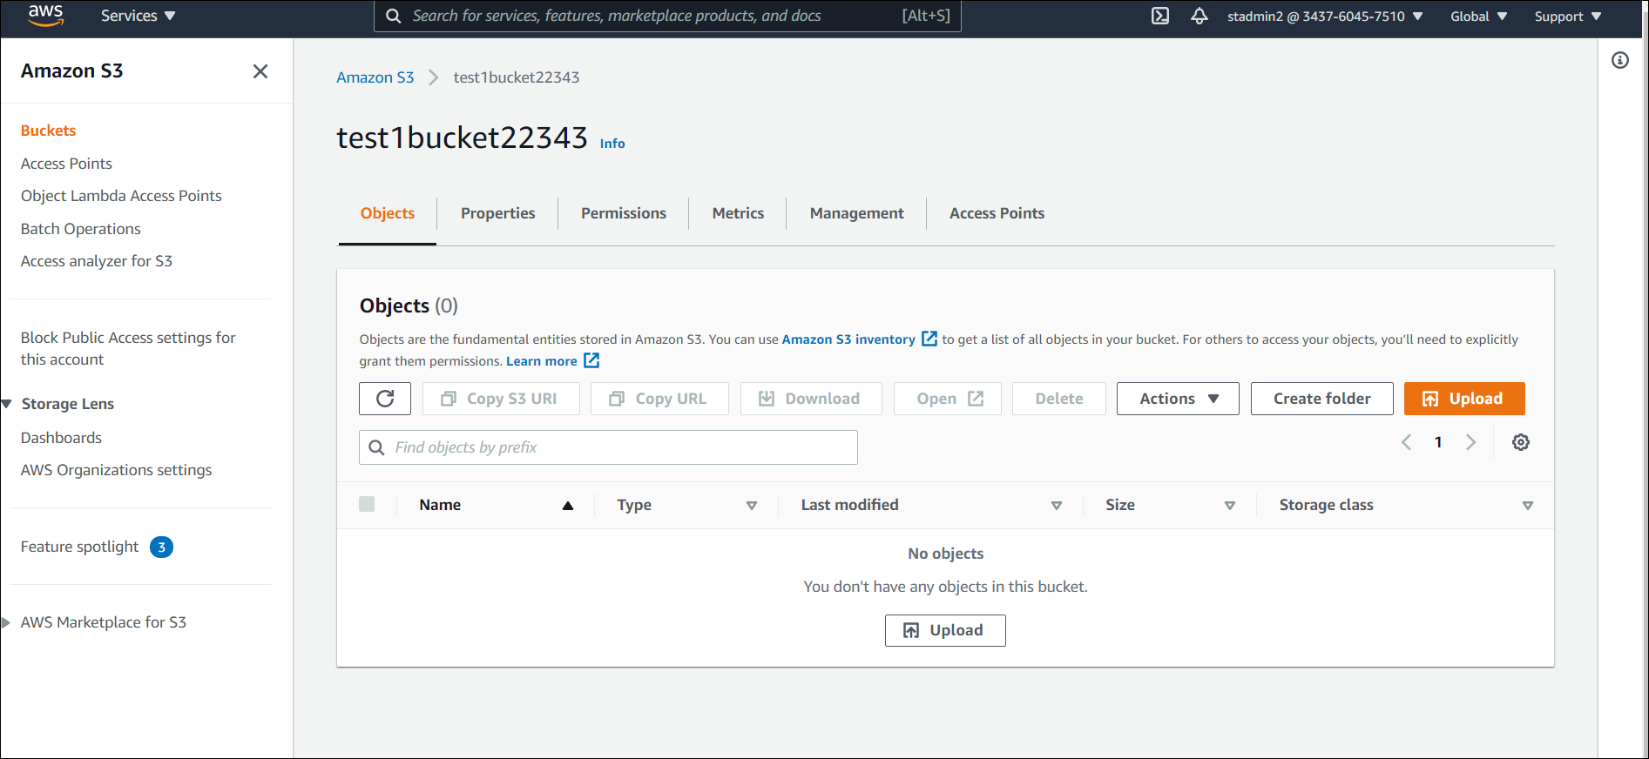

**Bucket has been enabled to host Static Website**

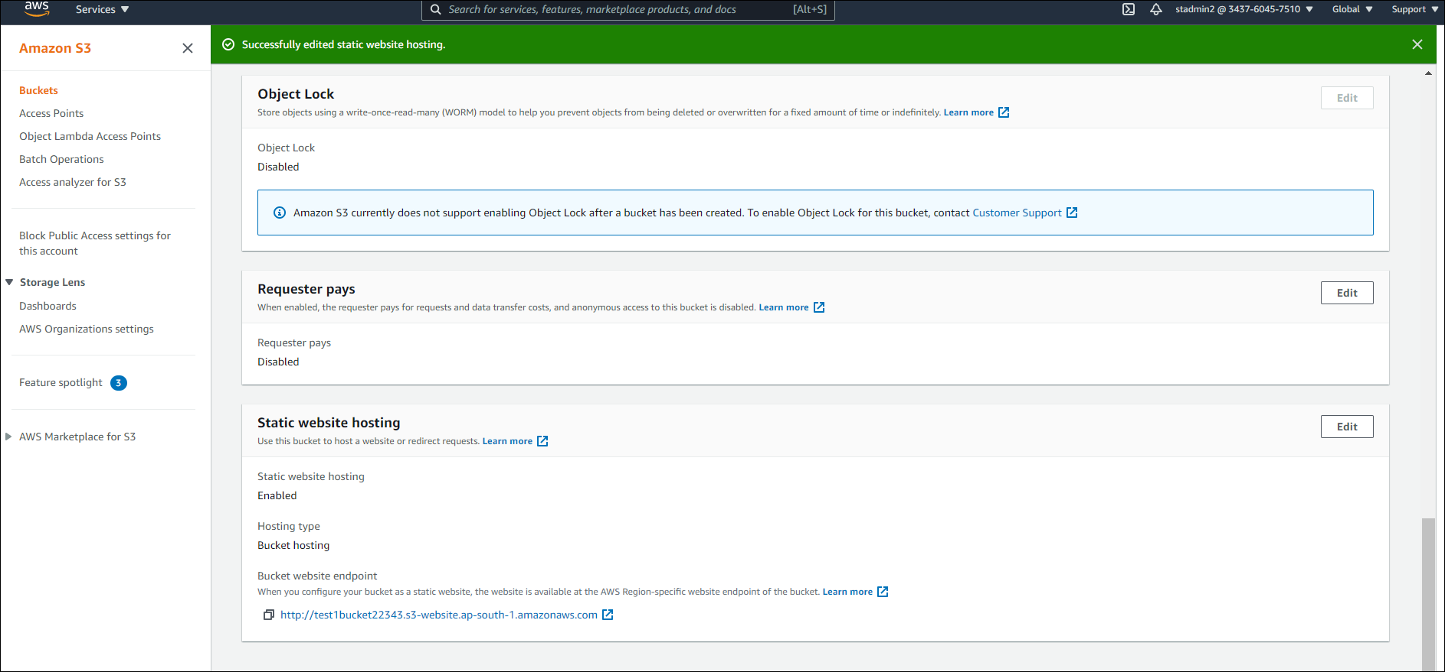

**Public Access has been provided to the bucket**

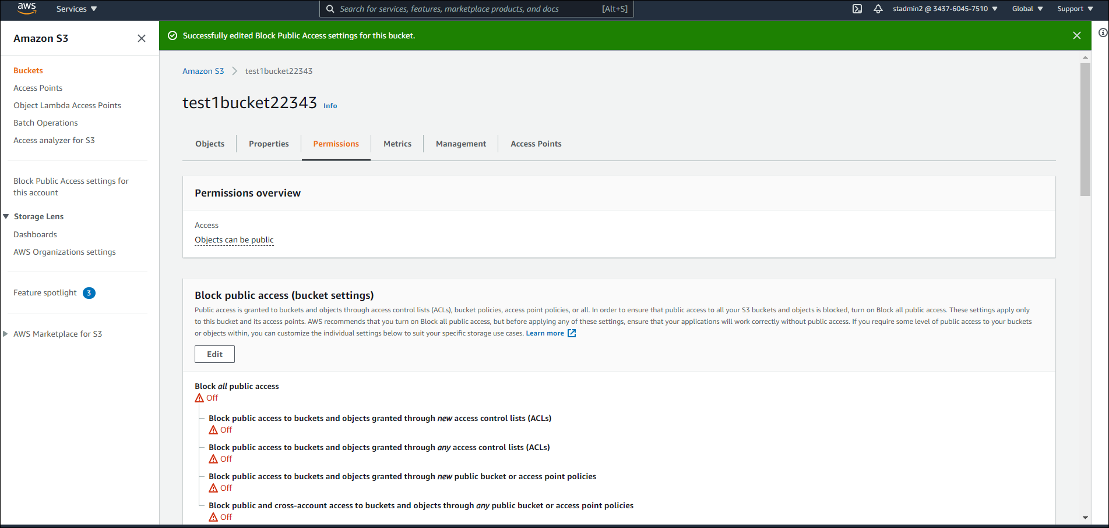

**Public can access the object in the bucket**

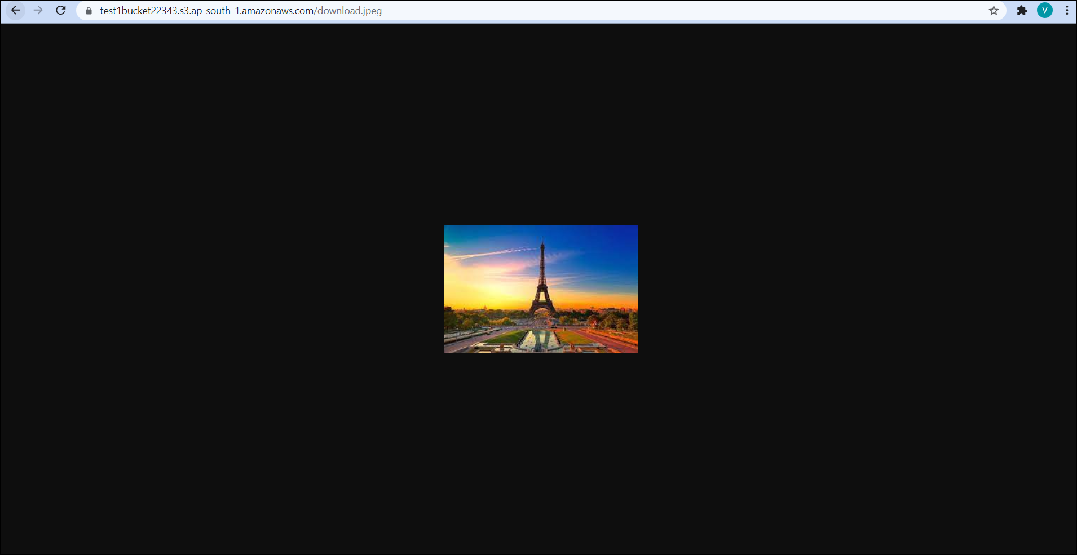

**Case 5: Create a billing alert and budget where you want to spend $500 maximum per month. You want to receive notification when your spending will reach 60% 75% and 90% of monthly budget. Check whether any bucket is created to store the logs.**

